- What happens to the gradient if you backpropagate through a long sequence?
A: Supposing neutral network is one kind of function that makes y = f_{w}(x), where x is input, y is output, w is a parameter that makes f can predict a value close to y. To get w value, we need to solve the equation of $\min_{w}(\sum_{x}{{|f_{w}\left(x\right)-y|}^{2}})$, we can simplify E = $\sum_{x}{{|f_{w}\left(x\right)-y|}^{2}}$ which is called error term. Thus, we need to get a group of w to make a minimum E. Then the refresh of w follow the equation below: $w^{+}=w-η*\frac{∂E}{∂w}$, where $\frac{∂E}{∂w}$ is called the gradient, $η$ is called learning rate that is a constant value. Then $\frac{∂E}{∂w}={(w-w}^{+})/η$. In a long sequence, ${w-w}^{+}$gradually becomes to 0, thus gradient gradually close to 0.

- What happens if you increase the number of hidden layer in the RNN models?
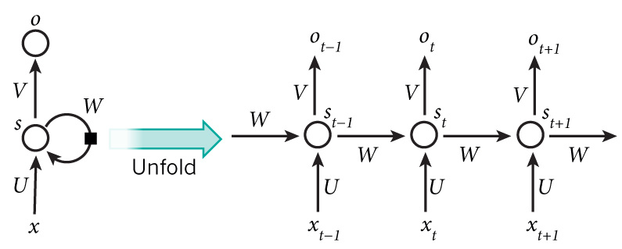
A: The upper is a simple illustration of a RNN model. At time t, the out O_{t} can be obtained by O_{t} = g(V. s_{t}), while s_{t} = f(U. x_{t} + W. s_{t-1}). If there is the number of hidden layer is n, then s_{t} = f(U. x_{t} + W. s_{t-1} + ….+ W. s_{t-n-1}), that mean more parameters will be included to predict current O_{t}. For neutral network, more parameters can promise to get a better value.

